**Ideation Phase**

**Define the Problem Statements**

|  |  |
| --- | --- |
| Date | 16 June 2025 |
| Team ID | LTVIP2025TMID38530 |
| Project Name | Grainpalette-A Deep Learning Odyssey In Rice  Type Classification Through Transfer Learning |
| Maximum Marks | 2 Marks |

**Customer Problem Statement Template:**

Create a problem statement to understand your customer's point of view. The Customer Problem Statement template helps you focus on what matters to create experiences people will love.

A well-articulated customer problem statement allows you and your team to find the ideal solution for the challenges your customers face. Throughout the process, you’ll also be able to empathize with your customers, which helps you better understand how they perceive your product or service.

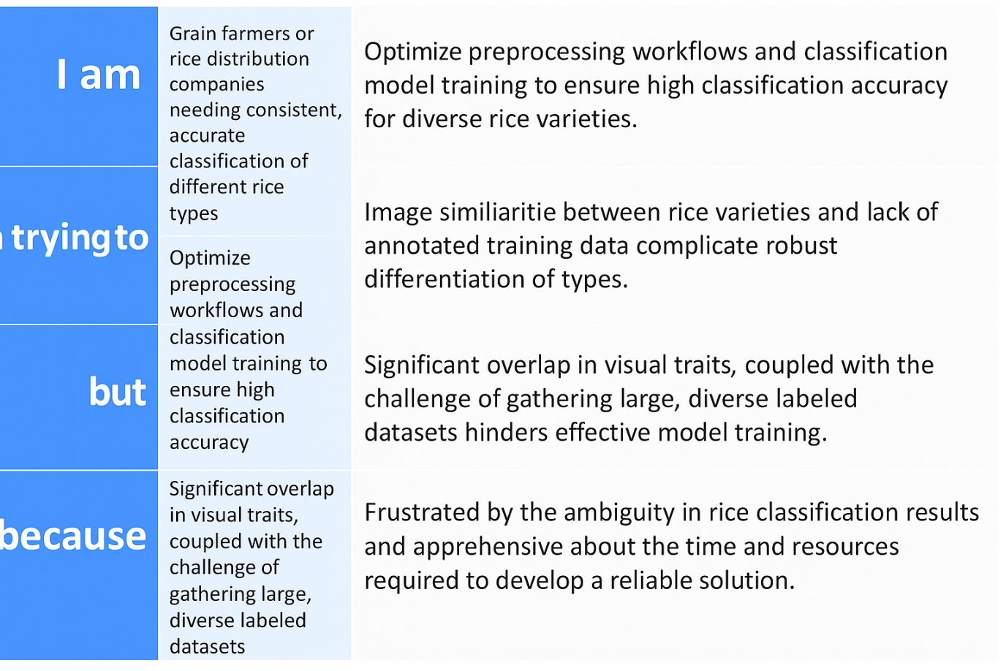

Reference: <https://miro.com/templates/customer-problem-statement/>

|  |  |  |  |  |  |
| --- | --- | --- | --- | --- | --- |
| **Problem Statement (PS)** | **I am (Customer)** | **I’m trying to** | **But** | **Because** | **Which makes me feel** |
| PS-1 | A rice exporter who requires consistent classification for quality control and global compliance | Implement a model that can classify rice types with high accuracy | Model accuracy drops across diverse rice types | The training data is imbalanced and lacks representation of all varieties | Frustrated, uncertain about meeting global export standards. |
| PS-2 | A machine learning engineer building a rice type classification tool | Build an efficient model using transfer learning with minimal labeled data | Pre-trained models struggle to generalize on the rice dataset | Visual similarity between classes and lack of annotated images | Overwhelmed, concerned about model robustness and real-world deployment |